Steps to add slave node:

1. Launch one new instance:

sudo yum install java-11-amazon-corretto-headless

1. Install Maven and Git
2. Goto Jenkins Dashboard( Master node)
3. Click on [**Manage Jenkins**](http://13.233.18.238:8080/manage/)

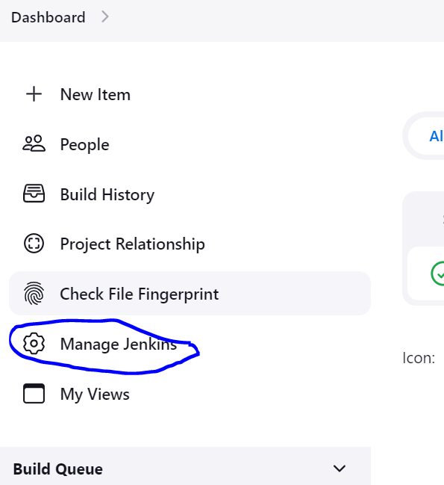

1. Click on • [**Nodes**](http://13.233.18.238:8080/manage/computer/)

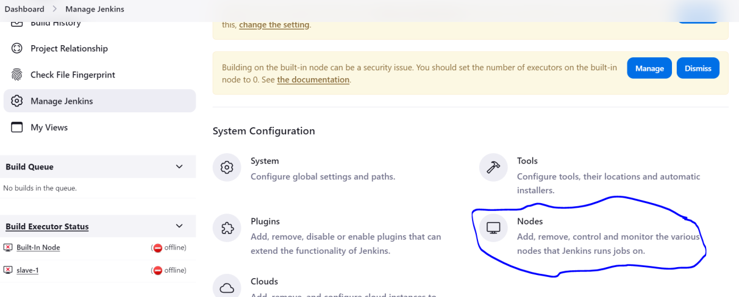

1. Then click **New node**

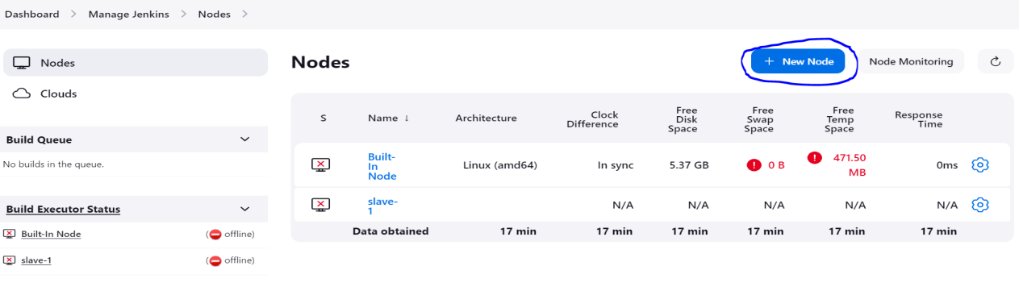

1. Then enter name of **node name** and then select **Permanent Agent**

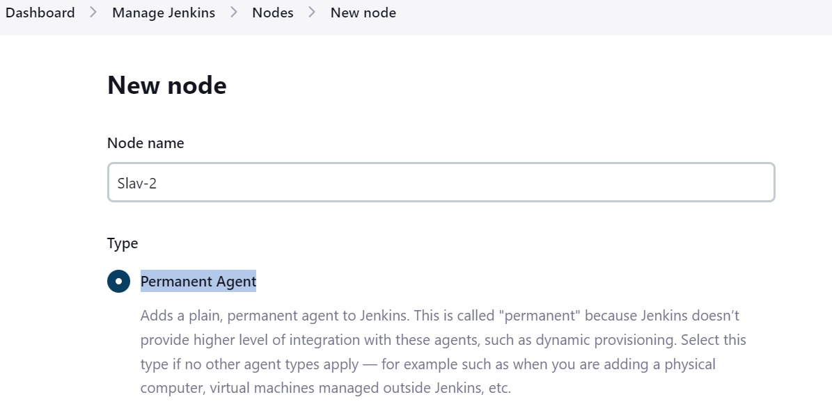

1. Then Click on **create** you navigate to next page
2. If you want **to change Number of executors**(how many job you want execute parallel)
3. Goto **Remote root directory**(The place where our output is stored on slave sever).

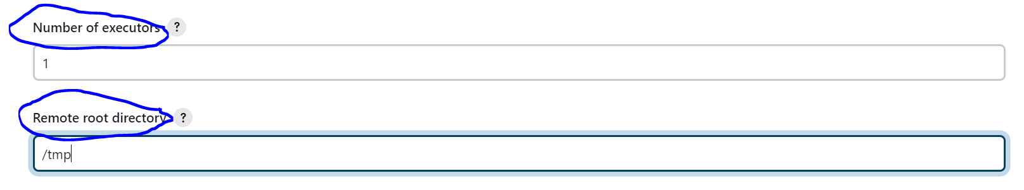

1. Then Goto Label and enter label name

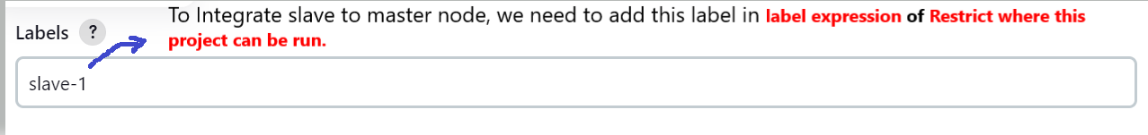

1. Then Goto **Usage and** select last option**(**Only build jobs with label expressions matching this node**)**



1. Then Goto **Launch method and select (Launch agents via SSH):**

* In Host enter private ip address of slave ec2 instance(new instance).
* In Credentials -- > first click on **add** -- > select **jenkins** -- >in **Kind** select **ssh username with privatekey**
* Then in **username** enter ec2-user
* Then select **privatekey** and click add button and then copy content of .**pem** file and paste here.

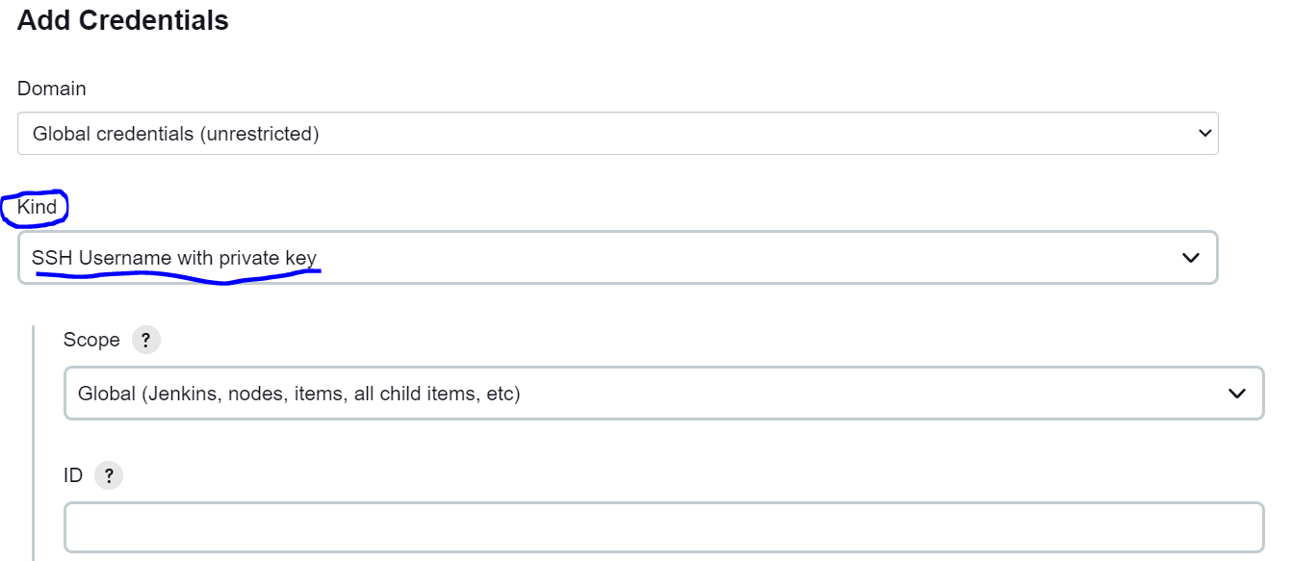

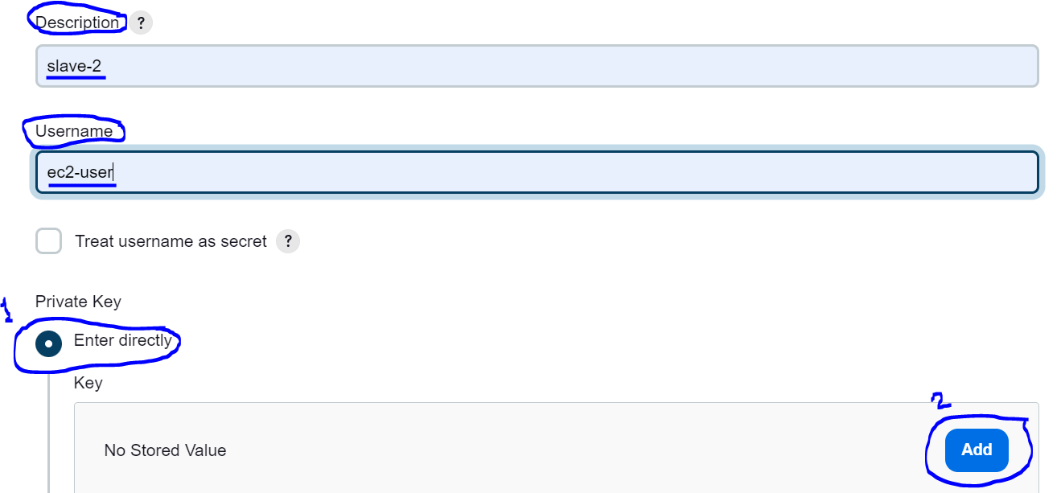

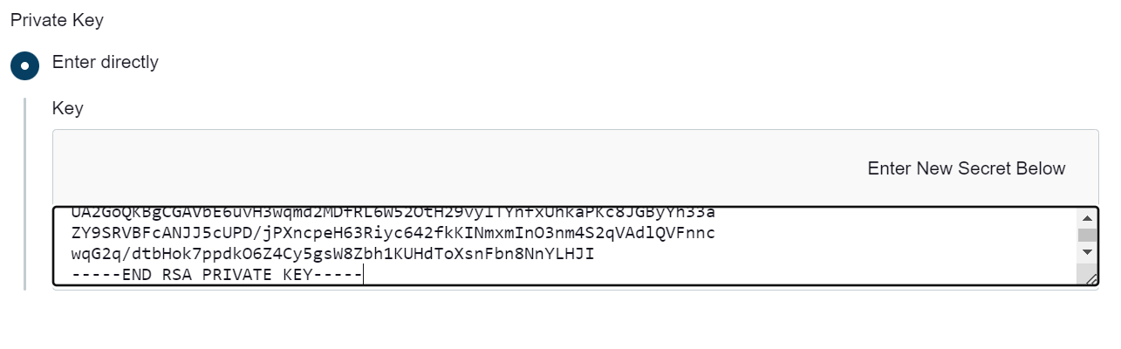

14. Once Credentials got create then in Credentials section select create credential(ec2-user (slave-2))



1. Click on save.
2. Goto Master Jenkins dashboard
3. Click on job name
4. Then click configure
5. Then select **Restrict where this project can be run and in label expression enter label of slave(which we given which creation of slave).**

